**Chatbot Deployment with IBM Cloud Watson Assistant**

**Phase 3: Development Part 1**

Submitted by

## Name:CG NIKHIL

## Nm id: au723921244012

## Email: cgsunny345@gmail.com

**BUILDING THE CHATBOT USING IBM CLOUD WATSON ASSISTANT:**

**1.Create a Watson Assistant Service:**

* Go to the IBM Cloud dashboard and click on the 'Create Resource' button.
* Search for 'Watson Assistant' and select the service from the list.
* Give your service a name and click on the 'Create' button.

**2.Design the chatbot's persona and conversation flow:**

* Imagine you are the owner of a small bakery and want to build a chatbot to assist your customers in choosing the perfect cake or bread.
* Name your chatbot: CakeOrderBot.
* Choose an avatar or logo that represents your bakery.
* Plan your conversation flow, considering common questions your customers might have, and the appropriate responses.

**3.Build the chatbot using IBM Cloud Watson Assistant:**

* Navigate to your Watson Assistant service and click on the 'Launch Watson Assistant' button.
* Click on the 'Create' button and select 'Dialog skill' as the skill type.
* Give your skill a name and description, and click on the 'Create' button.

**4.Define intents, entities, and dialog nodes:**

* Intents: Identify the types of questions or requests your users might have. For example, 'OrderCake', 'ChooseBread', 'AskAboutAvailability', etc.
* Entities: Recognize and extract specific information from user inputs. For example, 'BreadType', 'CakeFlavor', 'Quantity', etc.
* Dialog nodes: Design the chatbot's response flow, using conditional logic and variables to customize the chatbot's response.

**5.Train your chatbot:**

* To improve your chatbot's accuracy and performance, provide it with a set of example questions and responses.
* Train your chatbot using this training data and monitor its progress.

**6.Test your chatbot:**

Use the 'Try it now' feature in Watson Assistant to simulate user interactions with your chatbot.

Evaluate the chatbot's performance and make any necessary adjustments to improve its accuracy and user experience.

**BUILDING THE CHATBOT USING IBM CLOUD WATSON ASSISTANT.**

1.Import the required libraries:

import Json

from IBM _Watson import AssistantV2

from ibm_cloud_sdk_core. authenticators import IAMAuthenticatorte an instance of the Watson Assistant API by providing the necessary credentials:

Create an instance of the Watson Assistant API by providing the necessary credentials:

2.Create an instance of the Watson Assistant API by providing the necessary credentials:

authenticator = IAMAuthenticator('{apikey}')

assistant = AssistantV2(

version='2021-06-14',

authenticator=authenticator

)

assistant.set_service_url('{url}')

3.Define the assistant settings and create the assistant:

assistant_settings = {

"name": "CakeOrderBot",

"description": "Assistant to handle cake orders and inquiries",

"language": "en

}

response = assistant.create_assistant(assistant_settings).get_result()

assistant_id = response['assistant_id']

4.Create intents for your chatbot:

intent_name = "OrderCake"

intent_description = "Intent to handle cake orders"

intent_examples = [

"I want to order a cake",

"Can I get a chocolate cake",

"I need a strawberry cake"

]

create_intent = assistant.create_intent(

assistant_id=assistant_id,

name=intent_name,

description=intent_description,

examples=intent_examples

).get_result()

print(json.dumps(create_intent, indent=2))

5.Add more intents, entities, and dialog nodes to the chatbot using the create_intent, create_entity, and create_dialog_node methods.

6.Once your chatbot is complete, test it using the assistant.message method:

response = assistant.message(

assistant_id=assistant_id,

input={

'message_type': 'text

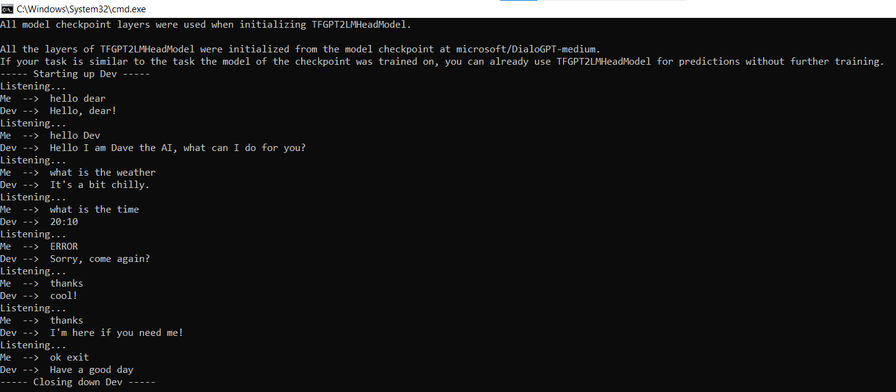

**CHATBOT'S PERSONA AND DESIGN THE CONVERSATION FLOW.**

Certainly, defining the chatbot's persona and designing the conversation flow are crucial steps in building an effective chatbot. Here's how you can go about it:

**1. Define the Chatbot's Persona:**

The chatbot's persona defines its character, tone, and how it interacts with users. Consider the following factors:

**a. Character and Tone:**

- Decide if the chatbot will have a specific character or be gender-neutral. For example, it could be a helpful assistant, a knowledgeable expert, or simply a friendly virtual friend.

- Determine the tone of the chatbot's responses. Is it formal, informal, friendly, professional, or something in between? The tone should match your brand and target audience.

**b. Name:**

- Give your chatbot a name that resonates with its persona. Choose a name that's easy to remember and pronounce.

**c. Purpose**:

- Clearly define the chatbot's purpose and the tasks it can assist with. Understanding its scope is crucial for designing the conversation flow.

**2. Design the Conversation Flow:**

The conversation flow is how the chatbot interacts with users. It should be designed to provide a seamless and engaging user experience. Here's how to do it:

**a. Identify User Goals:**

- Understand the main goals users have when they interact with the chatbot. What do they want to achieve?

**b. Create a Flowchart:**

- Create a flowchart or visual representation of the conversation flow. Start with a greeting, the main functionalities, and potential exit points.

**c. Map User Paths**:

- Determine the paths users may follow during interactions. What are the common user journeys, and how should the chatbot guide them?

**d. Define Dialog Structure**:

- In your chatbot development platform (like IBM Watson Assistant), create dialog nodes to structure the conversation. Each dialog node corresponds to a specific user turn or response.

**e. Handle Greetings**:

- Set up dialog nodes for greeting users. Provide a friendly welcome message to initiate the conversation.

**f. Manage Intents and Entities:**

- Identify and configure intents and entities that the chatbot needs to recognize to understand user queries effectively.

**g. Define Response Strategies**:

- Determine how the chatbot should respond to user inputs. Prepare responses, and consider adding variations for a more natural conversation.

**h. Implement Error Handling**:

- Create dialog nodes for handling cases where the chatbot doesn't understand the user's query or when users ask unexpected questions. Offer guidance or ask clarifying questions.

**i. Context and Personalization:**

- Use context variables to remember information across user turns, making the conversation more personal and coherent.

**j. Test and Iterate:**

- Continuously test your chatbot to identify issues, misunderstandings, or areas for improvement. Iterate and refine the conversation flow based on user feedback.

**k. Deploy and Integrate:**

- Once you're satisfied with the chatbot's performance, deploy it on your preferred platform or integrate it into your website, app, or messaging platform.

Remember that building an effective chatbot is an ongoing process. Collect user feedback and analyze chatbot performance data to make continuous improvements. This will help ensure your chatbot becomes a valuable and engaging tool for users.

**CONFIGURE INTENTS, ENTITIES, AND DIALOG NODES IN WATSON ASSISTANT TO HANDLE USER QUERIES**:

Configuring intents, entities, and dialog nodes in Watson Assistant is a fundamental part of building a chatbot that can effectively handle user queries. Here's a step-by-step guide to configure these components:

**1. Configure Intents :**

Intents represent the different purposes or goals behind user queries. By configuring intents, you teach your chatbot to recognize the user's intention. Here's how to do it:

- Log in to IBM Watson Assistant.

- In the Watson Assistant interface, navigate to the "Intents" section.

- Create and configure intents. For example, you might have intents like "Book a Flight," "Check Weather," or "Product Support."

- For each intent, provide examples of user queries that relate to that intent. Be sure to include a variety of examples to train the chatbot effectively.

**2. Define Entities:**

Entities are specific pieces of information that the chatbot needs to extract from user queries. Here's how to configure entities:

- In the Watson Assistant interface, go to the "Entities" section.

- Create entity types for the specific information you want the chatbot to recognize and extract, such as dates, locations, product names, etc.

- Provide examples for each entity type. These examples will help the chatbot identify and extract relevant information from user queries.

**3. Create Dialog Nodes:**

Dialog nodes are where you define how your chatbot responds to user inputs based on intents and entities. Here's how to create dialog nodes:

- In the Watson Assistant interface, go to the "Dialog" section.

- Create dialog nodes for each intent that you've configured. For example, if you have an "Order Pizza" intent, create a dialog node for it.

- Configure the responses your chatbot should provide when the associated intent is detected. You can use text responses, call actions, or connect to external services, depending on your requirements.

- Implement branching logic by setting conditions for when each dialog node should trigger based on the recognized intents and entities. This allows for context-aware conversations.

**4. Handle Fallback and Error Scenarios:**

Create dialog nodes to handle situations where the chatbot doesn't understand the user's query or when users ask unexpected questions. This is essential for providing a good user experience. Some tips for this:

- Create a "Fallback" node that provides a polite response when the chatbot doesn't understand the query and asks the user to rephrase.

- Design dialog nodes to handle common user errors or issues gracefully, such as "I didn't get that" or "Can you please provide more details?"

**5. Test and Refine:**

- Test your chatbot to ensure that it understands and responds correctly to user queries. Use the "Try it" feature within the Watson Assistant interface to simulate user interactions.

- Continuously refine your dialog nodes, intents, and entities based on user feedback and testing results. Add new examples to improve recognition.

**6. Deploy and Integrate:**

Once you're satisfied with your chatbot's performance, deploy it to your preferred platform or integrate it into your website, application, or messaging platform.

Remember that building an effective chatbot is an iterative process. Continuously collect user feedback and analyze performance data to make improvements and enhance the chatbot's ability to handle user queries effectively.